Arbeitsplan |  |  |  | - ng
Symbol | Was & wie? |  | erledigt |  | kontrolliert  
 | 25  24  22
 | 32
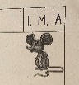 |   30
 | 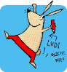

ng
 | 5

