Street art :
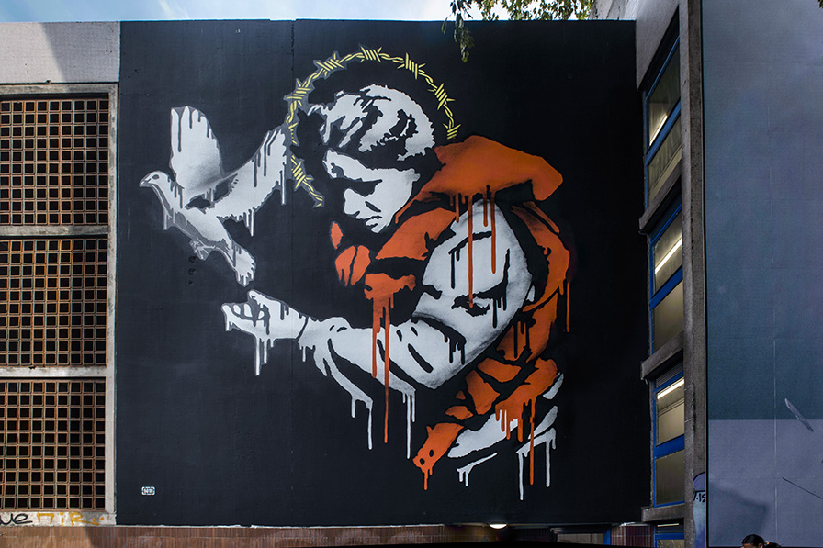
The artist : Groin
The title of this painting is Lady Refugee in 20th june 2023. It is in the street of François Raoult in Grenoble.
The artist is Goin and he is a French artist. He is an anonymous artist and happy to be. Today this artist is considered as “provocateur de genie” because the more part of his painting are engaged. He mainly practice his paintings in public places
On this picture there is a migrant woman who is wearing an orange life vest. On her head there is yellow barbed wired which represents the stars of the European flag. This barbed wired represents the harshness of European Governments and their refusal to welcome more migrants. On the left there is a dove which represents peace.
We have chosen this painting because it has an important meaning for us.

